Autumn term teaching strategy
May 2020
This document sets out the main principles of our delivery for the Autumn term in 2020/21. It is subject to change as the situation evolves. The content has been developed following conversations with both academic and professional service colleagues, as we look to the future and make plans for our students. Schools/Colleges are encouraged to adapt this document to their local situation as they wish, bearing in mind the key principles should stand when planning their changes.
A: Background
In the face of the COVID outbreak in March 2020 the University of Lincoln reacted quickly and moved all teaching to be delivered online within 24 hours. The academic year is now being completed online. We have achieved a huge amount over the last two months including
- Multiple sessions each engaging up to 150 participants for academics to learn how to utilise tools such as Microsoft Teams, Blackboard Collaborate and Turnitin in order to teach and assess our students online. Over 10,000 Remote Learning website views
- Delivery of multiple programmes and weeks of content online, much feedback has been positive and students have engaged well, but a less positive response to some types of more didactic content
- Delivery of an entirely online library service, including the introduction of new resources and delivery of online MASH and STATS workshops and one to one support for students
- Development and implementation of two new assessment approaches – Short Format Assignments and Time Constrained Assessments – alongside other online assessment formats unique to our disciplines, particularly practical assessments
- Development and approval of COVID temporary regulations to ensure our student outcomes were not unfairly impacted including a suite of Safety Net mechanisms.
- Adaptation of examination board processes to the online environment and to allow for Safety Net and Progress to Date mark calculations
- Confirmed changes to term dates, delaying the first day of teaching for AY 20/21 to October 12th 2020 for the majority of students
We now need to reflect on this intense period of activity and learning and move forwards with our plans for the next academic year. This document outlines this approach.
B: Teaching and learning approach: ENABLE
To ensure all our students receive an engaging and enjoyable learning experience, in the face of continuing uncertainty and challenge, we will deliver an ENgaged Agile Blended Learning Experience (ENABLE) approach to delivery. Whilst this approach has been developed in the face of the current challenges, there is recognition that this blended approach offers benefits to our learning environment and student achievement beyond these uncertain times.
“ENABLE at Lincoln will combine digital resources, interactions, collaborations and activities alongside face to face learning opportunities where feasible. Students will engage with a guided and structured approach to their learning, developing key digital skills alongside subject and professional outcomes, in a supportive and active on and offline community.”

ENABLE is based on five core principles:
- AGILITY – we will prepare our teaching and learning offer to react to an uncertain COVID situation. We will be able to both increase and decrease the proportions of remote delivery as required. We will support our whole community to this new way of working, with clear communications and expectations, underpinned by training and supported with high quality digital education resources.
- TIMETABLES AND LEARNING SCHEDULES – the timetable is the overall framework to planning and delivery, with scheduled sessions defining core touch points and activities (synchronous and asynchronous). Beyond the timetable, students will be supported to plan their “learning schedule” to ensure all learning goals are achieved.
- MAKING EVERY CONTACT COUNT – socialisation, connectivity and collaboration are important prerequisites for successful and engaging learning. Contact time, whether face to face or online, should be used to maximal benefit to support these requirements and build a strong learning community. Personal tutoring is a key element.
- CONSISTENCY, CLARITY and COHERENCE – a programme-level approach to delivery of ENABLE will support a consistent and clear approach for students. Our support for staff planning their delivery will be facilitated through a step by step, guided approach. The outcome will be an equitable experience for all our students.
- ONE COMMUNITY: A NEW ERA – the transition to ENABLE will challenge both staff and students alike. Our new teaching and learning identity should be an embodiment of our “One Community” ethos. Staff and students will work together to build a community of practice and approach to delivery that promotes and supports the development of 21st century teachers and learners.
C: Operational aspects of delivery
Curriculum design is often a compromise between a pedagogically appropriate approach and what is feasible to deliver, with considerations for learners, teachers and resources. In this changing (and challenging) time, this has never been more the case and we need to manage our redevelopment of delivery within the confines of pre-existing timetabling structures and curriculum outlines. There are some exceptions to this which are being worked on at local level, and mostly impact subjects which include practical elements. It is important to remember that the process of timetabling does not simply involve allocation of rooms - getting the right students with the right staff members is the first step. This means as we work to redesign our delivery:
- Programme and modular outcomes must remain the same, paying close attention to any possible impact on CRA requirements
- Minor modifications must only be used where necessary. Detailed guidance will be developed by the CDAQS and OQSP to assist teams with making decisions about changes and guide them through an approval process where necessary. Minor modifications that impact timetabling will not be possible for non-practical programmes.
- For timetabling purposes, the majority of MDFs submitted pre-covid will stand. For example, a request for two seminars and two lectures a week for a non-practical subject will be timetabled and this is the envelope in which the delivery must be planned. There are exceptions for practical programmes.
- This does not stop the setting of pre/post-work which does not necessarily need to be timetabled (although student expectation setting is key if this is the case). This is normal practice for most curricula where students would expect to do additional reading and pre-work prior to and between formal sessions. Students should then be supported to develop their “learning schedule” to include pre and post-session work
- Social distancing requirements for different teaching spaces are complex and changing. Safety will always be our first concern. Once firm plans are developed, programme teams will fit delivery in accordingly.
- For some practical modules/programmes, changes to physical requirements may necessitate MDF alterations and these discussions are active
- Our aim is for all modules to have at least one session of face to face contact per week. In a typical module that utilises small group seminars, an A/B Model will be applied by timetabling following programme team discussion. The example (section L) shows a 20-student group with twice weekly seminars and the principles can be applied to other situations.
- Personal tutoring sessions will not be scheduled centrally. Schools/Colleges need to ensure these are formally planned with e.g. the Senior Tutor leading this process. Information will need to be shared with timetabling so that the dashboards can be updated.
- We aim to offer an equitable experience for all students, ensuring face to face opportunities are equally distributed and that online learning is delivered in consistently engaging ways.
- Other teaching formats such as placements, work experience and trips also require planning. As the situation evolves generic guidance will be produced but in the first instance Schools should discuss with their DoE for advice.
D: Student voice and student support
Working with our students will be key to ensuring successful delivery of this approach. Programme teams must include students, where possible, as part of their team during the design of their delivery. An opportunity to feedback on their previous semester experience of online learning is essential to feed into discussions around what works. This should be followed up with further work with students as plans develop. The Students Union will be a key member of the oversight group, and Schools should ensure students are represented within their working groups where possible.
Academic and pastoral support for students is essential whilst we manage the transition to a new way of teaching and learning. All students will require induction to blended delivery (section H) but this has to be supported by Personal Tutors. A strand of work led by the University Senior Tutor will consider development of our PT system in the blended environment, and further training offered as required.
Additional measures need to be considered for shielding students, so that they are able to complete their studies where feasible. An approach to this is currently being considered but this is likely to be on a programme by programme basis as required.
Other students may also require additional support and a small piece of work is currently being carried out by LHERI looking at Covid’s impact on our APP students. The outcomes from this will be considered as they are available.
E: Quality and standards
Quality and standards are key considerations as changes are planned. CMA regulations must also be considered by programme teams. Whilst most programme changes will be within the confines of current programme descriptions, there will be aspects that require oversight from the CDAQS. It is important that we are clear about what does and does not constitute a minor modification. Assessment changes to realign with changes to delivery or refinement to align with the assessment framework will be actively encouraged, using the sign off process developed by PBI and overseen by OQSP.
OQSP and the CDAQs are developing a clear “check list” to guide programme teams through these decisions and processes.
Development of new teaching materials presents an opportunity to check accessibility requirements and support will be provided to colleagues who have not yet engaged with this training. A check list approach and supporting software (Blackboard Ally) will be implemented.
F: Stages and timeline
The following timeline is based around a five-stage approach: Analysis, Design, Development, Implementation and Evaluation, with several processes for programme teams to undertake within each stage. It is suggested that Colleges and/or Schools produce a more detailed version of this timeline, including key milestones and ensuring oversight of their programmes.
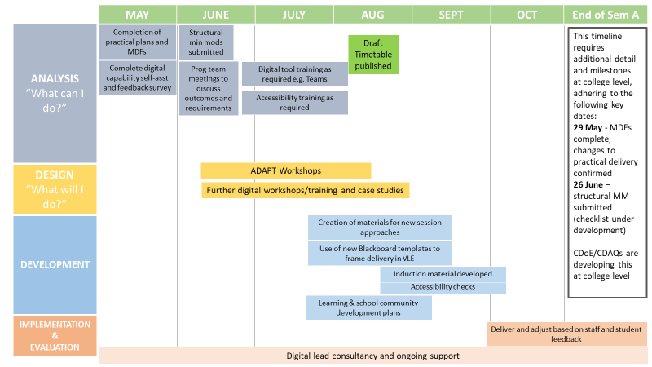
One programme from each College will act as a “pathfinder” undertaking the transformation process by early June and therefore shaping the approach for other programmes.
G: Support: ADAPT workshop and further digital training and case studies
The move to a blended delivery model requires further rapid upskilling of colleagues to enable the redesign of module delivery and to ensure digital tool capability. Colleagues need to assess their own capabilities and feedback on development needs and any gaps in provision. A bespoke survey has been developed for this process, the outcomes of which need to be discussed by the programme team as a group prior to beginning the redesign process. This will identify any skill gaps and further support needs, and asks for reflections on particular challenges around future delivery.
Design of the approach at programme and modular level will be supported by a new version of the highly effective ABC curriculum design process: Activity Development and Agile Planning for Teaching (ADAPT)
The ADAPT workshop is designed to be an engaging hands-on workshop for the development of a blended approach. In 90 minutes, using a digital card format, teams can work together to create a visual ‘storyboard’ outlining the type and sequence of learning activities (both online and offline) required to meet a module’s learning outcomes. One module is redeveloped in detail and this framework is then applied elsewhere.
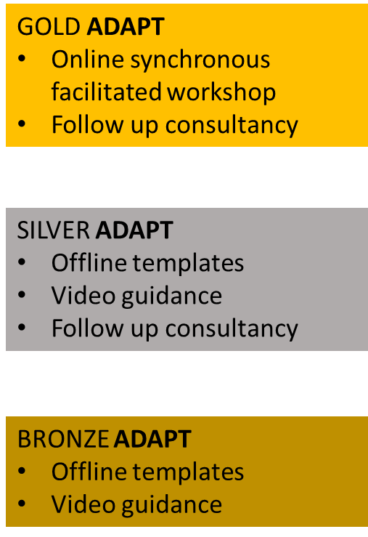
Three levels of support are offered and the one selected will depend on the team’s experience and expertise. School teams should discuss which level is appropriate for each programme and follow up with the digital team.
All redevelopment needs to take place alongside the logistical and practical plans for the timetable, and programme teams will need to approach this with a flexible mindset.
Digital consultancy and further workshops covering the range of digital teaching and assessment tools offered will be available to all.
The pathfinder modules will act as example structures and will be available to all teams as design processes progress. Case studies are a key resource for other teams and these will sit alongside digital case studies based on previous experiences which are being published regularly.
H: Transition and (re) Orientation Activities
The evolution of our transition and orientation activities that support the arrival and induction of our new students is essential to ensure they are properly prepared for the ENABLE approach. Orientation activities for those returning from previous years of study must reset expectations for the blended experience and ensure appropriate digital skill levels. Induction periods are critical for preparing students for academic study, introducing independent learning, developing digital literacies, and preparing for arrival at Lincoln. They provide us the opportunity to connect students with a wide range of support services, whilst enabling them to make contact with Schools, personal tutors and most importantly each other.
- Under the Lincoln First Year (LFY) banner, initial planning is now underway for a co-ordinated approach to supporting Transition to Higher Education study, which will focus on the skills required to study, learn and flourish in a blended teaching environment for all students.
- This will be built upon last year’s LFY projects and blending the best of the App (Countdown to Lincoln) and the Module (Getting Ready for Lincoln) content delivered via a web platform. Content will be redeveloped to reflect our move towards blended learning and ensure activities enable our principles to be embedded throughout. The Digital Student Life Team have already created content to support the alternative online assessments which can be used with minimal modification.
- A ‘building block’ approach will be used to create a meaningful pathway for students, starting early in the summer (subject to CDM plans) potentially using the ‘Lincoln Island’ game as a starting point for the student journey to Lincoln, and building up through more detailed information and activities to culminate in ‘Get Started’ week.
- Re-orientation activities will set returning students expectations and ensure digital readiness, as well as transition to a socially distanced campus.
The building blocks across all years of study will include:
  - Generic (internal & external) study skills content
  - Student created content
  - Information resources and activities
  - Preparation for the changes to campus
  - Academic generated content/tasks
  - Links into ‘Get Started’ Week and activity on campus
  - Social activities to build a connected online community.
A further piece of work is required around student digital hardware readiness, including any “no hidden costs” issues which have been flagged at programme level.
I: Building a community and supporting students
In a blended learning environment, it is more important to take active steps to avoid potential feelings of isolation. More time will inevitably be spent online, and less time in the classroom, and this can make it more difficult to pick up on cues that someone is struggling. Programme teams will need to recognise and ensure community building is a key consideration whilst redesigning their delivery approach. The SU Academic Societies should be part of this and provide an excellent opportunity to engage more informally with students.
The redesign process should be seen as a “journey” and teams will be encouraged to include current students in their discussions about what works and what requires improvement. This will help the entire team consider their identity and reinforce their sense of belonging. Regular programme team meetings and meetings with student representatives should be scheduled, in addition to formal committees, to specifically review how the programme community is working as a whole and to seek ideas to strengthen the community.
The previous resources and support for teams produced by LALT to support peer learning initiatives will also be adapted for use digitally, and further ideas around “digital buddies” are also being considered. We also need to adapt our plans for further roll out of the Engagement Priority Marker in the current situation, bearing in mind there will be no additional resource for this activity.
J: Attendance monitoring
There are several questions around how the university will implement attendance monitoring beyond the scheduled face to face sessions. A new approach and policy is likely to be required. Whilst individual module tutors will need to be pro-active in following up on activities, monitoring and adding to any chat rooms or discussion boards being used, and checking in with groups and individual students, some form of online attendance monitoring requires consideration. This discussion will be led by the Academic Registrar as part of the curriculum group’s activities.
K: Oversight
A curriculum working group, feeding directly into SLT (LM chair, membership includes the SU), will oversee this process and subgroups will be formed as required to focus on specific areas of activity. Initial subgroups will work on “Get Started Week” and Accessibility requirements and others are under discussion. A working group should be set up in each School to perform the same function, with the School/Department Director of Teaching and Learning as chair. Weekly catch ups between SDoTL teams and CDoEs are essential.
Whilst this document mainly talks in terms of a programme approach to redesign, in some areas this may be more effective at school level, and in other areas there are challenges around shared modules and matrix systems. Teams will need to flex and adapt to these issues, and ensure issues are communicated with CDoEs where necessary so that central processes can support where needed. Clearly for some PGT programmes being delivered across the Summer, a streamlined approach to this will be required and this is under discussion with the relevant areas.
L: Examples of A/B models and module conversions
- A/B seminar example
Pre-COVID |  | Post-COVID ENABLE approach
- Two seminars per week  - 20 students in group  - 6 Learning Outcomes per seminar |  | - Two seminars per week  - 10 different students in each group  - Seminar therefore repeated twice
Students all carry out pre-work prior to seminar by watching short video introduction
- LO A1 & A2 plus B1 & B2 Theory/background info (didactic)
Seminar A  - LO A1 & A2 Theory/background info (didactic)  - LO A3, A4 & A5 Application scenarios(interactive)  - LO A6 Conclusions and lead into next session | Seminar B  - LO B1 & B2 Theory/background info (didactic)  - LO B3, B4 & B5 Application scenarios(interactive)  - LO B6 Conclusions and lead into next session | Seminar A, group A  - LO A3, A4 & A5 Application scenarios (interactive)  - LO B3, B4 & B5 Application scenarios(interactive) | Seminar B, group B  - LO A3, A4 & A5 Application scenarios (interactive)  - LO B3, B4 & B5 Application scenarios(interactive)
Students all engage with online wrap up session covering LO A6 and B6
OR
Asynchronous discussion forum covering A6 and B6
In a complete lockdown scenario, the split seminar groups would still meet virtually via Teams for a synchronous learning experience in small groups

- Module conversion example – practical (e.g. science subject)
Pre – COVID | Post COVID ENABLE approach
24 lectures (2 x weekly) and 4 practical sessions. Introductory and Revision Sessions in lectures  5 x Learning Outcomes (LO) (4 theory, 1 Practice/Skills) assessed by coursework and examination | 28 x Learning Events*  4 x Learning Tasks# to cover LO 1-4 (each for 3 weeks’ duration) covering each learning outcome / topic area.  2x Practical Exercises to cover LO5 (held in specialist space where possible or virtually)  1x Revision Session  Assessed by coursework and online time-constrained assessment (TCA)  * Timetabled learning events held to provide plenary and revision sessions as well as informing guiding and supporting students in their completion of Learning Tasks.  #Learning Tasks consist of:  - Plenary lecture (synchronous online presentation or asynchronous video recordings) to introduce topic area and learning outcomes  - Whole-class info-searching in groups, leading to…  - Construction of hyperdoc notes (in OneNote Classroom Notebook)  - An Application Exercise requiring student groups to apply the disciplinary concepts and ideas of the module to challenging problems and/or applied contexts.  - Completion of weekly online quizzes to support and guide learning  - Documenting of Learning in Journal/portfolio (OneNote Classroom notebook)
In a complete lockdown scenario, the practical activities would be replaced by videos and demonstrations followed up by synchronous discussions

- Module conversion examples – non-practical (“theory”) module (e.g. social science)
Pre-COVID | Post-COVID ENABLE approach
15-credit module Theory/Seminar-based module:  - 60-80 students in module group  - One Interactive lecture per week (60-minutes)  - One task-based or computer-based seminar per week (90-minutes) with three groups of 20-25  - 2/3 key learning outcomes per week  - Assessment strategy: Written report and computer-based assessments | Alternative to lecture:  - Video-based weekly episodes of 5-10 minutes that cover key curriculum topics – these will form a ‘Module Boxset’ (Theory)  - Online activities in the form of pre-reading, case studies, and sensor checking will bookend each episode (Application)  - Each week will conclude with a 30 -min synchronous online session/webinar with the group (Consolidation, Synthesis and Evaluation)
Seminar delivery:
All students seen F2F over a two week period
- A/B repeat model would require three seminars per week (10-12 students per seminar) - over the two-week period all 60-80 students would have been exposed to the seminar session
- The face-to-face seminar per week will enable key ‘assessment’ focused learning activity connected the ‘Module Boxset’ and additional online activities and resources
- Use as Microsoft TEAMs /OneNote Classroom Notebook as a location to co-produce resources with students, developing shared working examples.
- During a student’s time off from the weekly seminar, tasks will be set via Microsoft TEAMs to facilitate additional learning

In a complete lockdown scenario, the split seminar groups would still meet virtually via Teams for a synchronous learning experience in small groups

- Module conversion example – practical (performance-based) module (with thanks to Dr Andrew Westerside, LSFPA)
Pre-COVID | Post-COVID ENABLE approach
30 credit module  - 15 students in module group  - 3 hours studio time per week  - 3 hours of seminar time  - Assessment – in studio rehearsal and digital portfolio  Studio session detail  0m-15m Introduction to the session aims and the section/sequence of material  15m-45m Students read through & discuss the text in small groups of 3-5  45m-1h15 In small groups, students begin to experiment with directing approaches to the scene  1h15-1h30 Short, full-class check-in – what are they finding? What’s interesting?  1h30-1h45 Break  1h45-2h30 Continue small group work, rotating directors and exploring ideas  2h30-3h Full group exploration of scene, with self-selected director from the group | Studio sessions  - Only half class (7-8) able to attend at a time, slot decreases to 90 mins per group  Delivered online pre session Introduction to the session aims and the section/sequence of material  Delivered online pre session Students read through & discuss the text in small groups of 3-5  0-30m F2F In small groups, students begin to experiment with directing approaches to the scene  30-45m F2F Short, full-class check-in – what are they finding? What’s interesting?  Removed Break  45-1h15m F2f (Shortened as smaller class size) Continue small group work, rotating directors and exploring ideas  1h15-1h45 f2f (Shortened as smaller class size) Full group exploration of scene, with self-selected director from the group
Seminar delivery:
Entirely online, mix of synchronous and asynchronous activities e.g.
- Watching and feeding back/commenting on video/film
- Discussing and unpacking close readings done in advance of class
- Tutor-presentations (mini-lectures of 20-30 mins)
- Small-group discussion and problem-solving followed by feedback to the group
- Small-group research and presentation
- Full group discussion and debate

In a complete lockdown scenario, the studio session would revert to a three-hour slot, and utilise Bb Collaborate rooms for students to work in small groups on the material remotely, with the tutor moving between rooms. Adjustment in assessment would be needed to align with this.
M: Further links and resources (evolving list!)
https://remoteteaching.blogs.lincoln.ac.uk/ - further case studies are being developed and added
QAA - https://www.qaa.ac.uk/docs/qaa/guidance/assessing-with-integrity-in-digital-delivery.pdf
(The QAA webpage also includes several other sets of guidance)
Office For Students - https://www.officeforstudents.org.uk/advice-and-guidance/coronavirus/
Advance HE – case studies and resources - https://www.advance-he.ac.uk/
OneHE - https://onehe.org/online-teaching/
Crowd sourced advice on teaching in the context of Covid-19 - https://docs.google.com/document/d/1yBE1cCqJ_4M-JZ62K4CefmYsZugqAWkGmZmdwESt0IM/edit#
LinkedIn Learning – range of resources, free for UoL staff and students
Tips from Deakin - http://dteach.deakin.edu.au/2020/03/17/teaching-online/

