Collaborate Ultra & Recording Teaching Events
This guide outlines some basic advice and tips to support recording inside of Collaborate Ultra
Blackboard Collaborate Ultra is the core platform for online live teaching events. Below we have some guidance to support using the features of the system as well as some considerations for use during sessions.

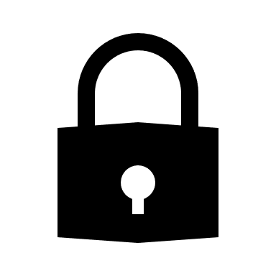
Moderator access
Only moderators can start the recordings inside of collaborate ultra. Giving you control over how and when the content is recorded. If you are working with multiple tutors who need this functionality, make sure to switch their role to 'moderator' when they join the room

What gets recorded?
The recording can record audio, video, screen shares and any messages left by students/staff in the chat box.
Please note that the messages from the 'chat' box are replayed real-time with the recording when viewed in Blackboard Collaborate. If the video is downloaded and uploaded to Panopto, it will lose this functionality

Sharing the video
There are two methods of sharing the video with students. One is via Blackboard Collaborate Ultra and the other is to download the video and upload to Panopto. We would recommend choosing one method to help students with consistency of accessing the materials.

Share in Blackboard Collaborate Ultra
When recording inside of Blackboard Collaborate Ultra, the session is recorded and saved inside of the blackboard collaborate ultra area on the module site. All participants will have access to the recording as well as see the messages that were sent throughout the recording
Functionality:
- Audio
- Video
- Chat messages
- Screen recordings

Download & upload to Panopto
You can download the recording from Blackboard Collaborate Ultra and upload to Panopto. Please bear in mind that this will remove chat messages. However, gives you some extra options and elements which need to be considered.
Functionality:
- Audio
- Video
- Screen recordings
- Closed captions
- Playback speed
- Make notes
Closed captions in Panopto are automatically generated, so can contain minor errors. Closed captions are supplementary and the source of 'truth' is the original audio and not the closed captions.
Students are encouraged to seek clarification with their teaching staff wherever necessary and/or report any inaccuracies that undermines meaning.

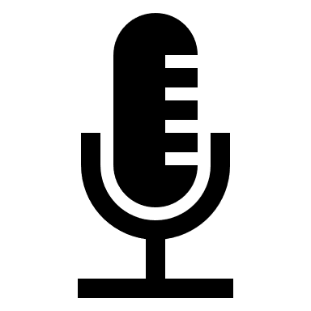
Opting out
ALL participants should be advised that they are free to opt out and switch off their cameras and microphone. Participation is voluntary, but we recommend students engage with the teaching as much possible to ensure getting the most out of the learning experience.

